#Josh Hayter

#CECS 225

#Homework 4 MIPS Conditional Operations

#Sotheanith Sok

#Exercise 1: if/else logic

addi $6, $0, 0x30 #$6 = 0x30

slt $7, $4, $6 #Is $4 < $6?

beq $7, $0, not_less #If $4 < $6, do:

addi $1, $0, 0x3000 #$1 = 0x3000

addi $2, $0, 0x6000 #$2 = 0x6000

not_less: #else

beq $4, $3, equal #if $4 == $3 do:

addi $3, $4, $0 #$3 = $4

equal: #else

sub $5, $4, $3 #$5 = $4 - $3

#Exercise 2 : while loop exercise

addi $3, $0, 4 #$3 = 4

startWhileLoop: #Start loop

beq $4, $3, endWhileLoop #if ($3 = 4), end loop

add $4, $4, $2 #else, $4= $4+ $2

j start_loop #restart loop

endWhileLoop: #end loop

#Exercise 3 : for loop exercise

addi $1, $0, 10 # $1 = 10

addi $20, $0, 20 # $20 = 20

startForLoop: # Start Loop

slt $2, $1, $20 # Is $2 < $1?

beq $2, $0, endForLoop # if $2 >= $1, end loop

add $1, $1, 1 # else $1++

sub $20, $20, 1 # $20--

j startForLoop

endForLoop: # end loop

Exercise 4:

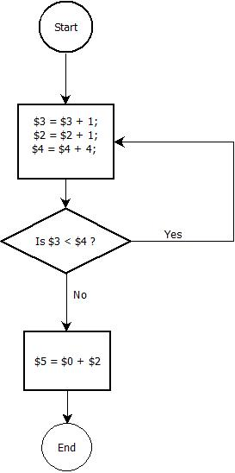

Exercise 5:

